


FY24-25 ANNUAL REPORT

“Your library is enriching a vibrant community with access to information and technology, serving as a community gathering space, fostering readers, and stimulating minds.”


Library Visits Total Items Checked Out Website Visits

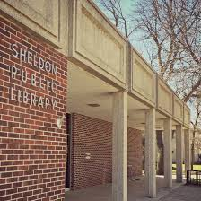

19,043 38,556 8,853
33% 3.7% 17.8%
PROGRAMS PROGRAM ATTENDANCE
216 3,705

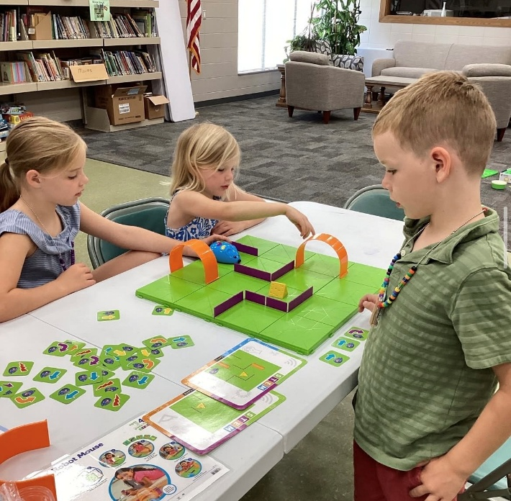
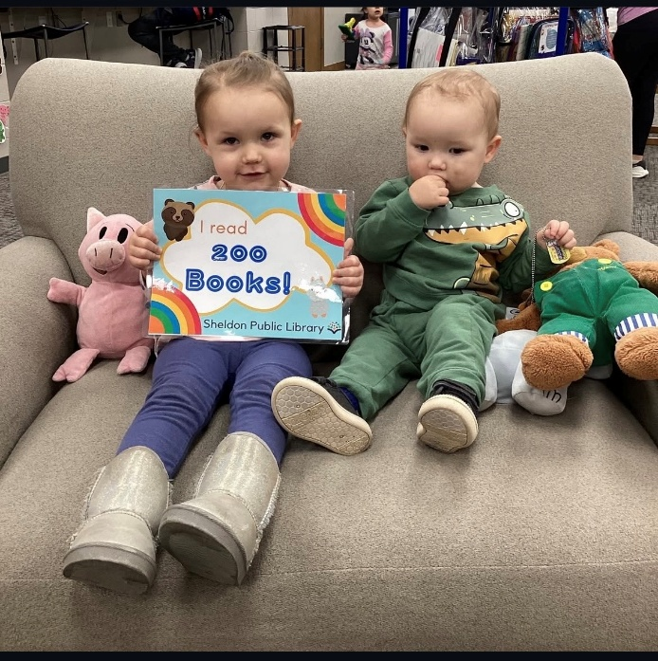

1,000 BOOKS BEFORE KINDERGARTEN SUMMER READING PROGRAM

